$\left|x-8.168\right|=0.314$

__________________________________________

Statistics show that a four-year-old’s vocabulary is likely to consist of 375 ± 125 words.
What equation would represent the expected upper and lower bounds?

$\left|x-375\right|=125$

_________________________________________

Solve the equation:

$\left|x-4\right|=\left|x-8\right|$

6

__________________________________________

Solve the inequality:

$-\left|\frac{1}{2}c-3\right|≤1$

All real numbers

__________________________________________

Solve the inequality and graph the solution set on a number line.

$24-\left|6k\right|<0$

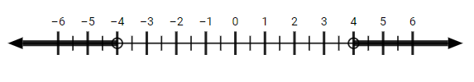

__________________________________________

Solve the inequality:

$2-\left|6+12x\right|>-28$

(-3, 2)

__________________________________________

Solve the inequality:

$3\left|x+2\right|-31<5$

(-14, 10)

__________________________________________

Solve the inequality:

$2\left|x+5\right|≥40$

$(-∞,-25]∪{} [15,∞)$

__________________________________________

Throughout the day, an internet service provider’s super speed plan provides 100 Mbps download speeds with a tolerance of 45 Mbps.
Write an equation representing the minimum and maximum expected download speeds on the plan.

$\left|x-100\right|=45$

__________________________________________

Solve the equation:

$\left|6+3x\right|-8=19$

{-11, 7}

__________________________________________

Solve the inequality:

$\left|3-y\right|+9<9$

No Solution

__________________________________________

Find the Sum of the solutions to the equation:

$4-\left|2x-4\right|=-8$

4

__________________________________________

Solve the inequality and graph the solution set on a number line.

$\frac{\left|x-5\right|}{4}≤5$

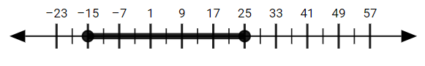

__________________________________________

Regulation tennis balls must measure between 7.854 and 8.482 inches in circumference. Write an equation representing the minimum and maximum circumference measurements accepted for competition-use tennis balls.

